# Devicelist

The devicelist is the part of the sensorlist that contains all the devices that are connected to NavVision together with all the specific data concerning that connection. When opening a sensorlist framework you will see 2 tabs from which you will have to choose the tab named “devicelist”. (see Figure 9‑1).

## Introduction

The devicelist is separated in different columns which need to be filled with the right data. A few of the columns are optional and merely there for you to put your own comment. These columns are white. The other columns are almost all necessary for the proper working of the system and are colored differently. These colors belong to the different groups which can be divided into interface, port and device. Columns with the same color belong to the same group.

By defining all the devices the right way in the devicelist you will get a properly closed network once you import the sensorlist into the system. To do so you need to make a plan on how you need the network to be applied, a list of all the devices and a list of how everything will be connected. To make it visual it is best to make a single-line drawing of the topology for reference (see Figure 10‑1).

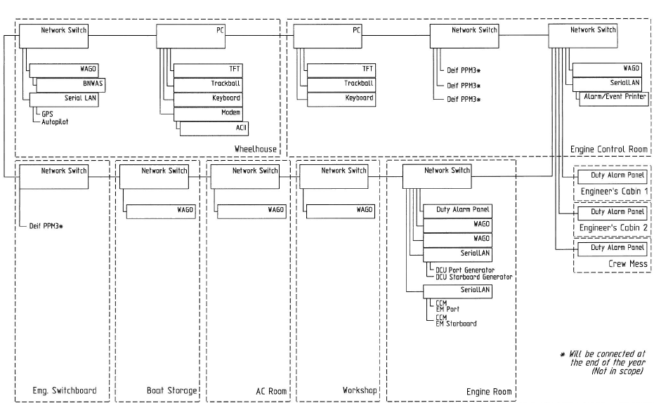

Figure 10‑1: single line drawing

## Columns

The columns in the devicelist are labeled in the first row. The fields underneath can be filled with free text or have a drop-down menu where you can choose a tag. These tags are mandatory and the devicelist won’t except tags that are not in the list for these columns.

The following columns are in the devicelist:

|  |  |  |
| --- | --- | --- |
| **Column** | **Type** | **Description** |
| Import Result | Text | Checking value by NavVision |
| ID | Text | Any given ID you want or need. |
| Device | Text | Identification of the device where the sensor/control or serial device is connected to. This text should be unique for each FT NavVision® device. The text is case sensitive |
| Comment | Text | Freely to add comment |
| Location | Text | Identification of the substation where the sensor/control is connected to in the FT NavVision® system. (i.e. ER or WH) |
| Protocol | Select | The protocol used for serial connections. (for options see Table 10‑2) |
| Interface | Text  (Index) | Choose the appropriate interface to distinguish the different interfaces in the system (for options see Table 10‑3) |
| Port | Value  (Index) | Port number on the FT NavVision® interface. For MOXA serial servers it’s 1 or 2. On a WAGO it’s always 1. |
| Source | Value  (Index) | Identification of multiple devices on a bus protocol. Used for example for Mod bus (ID byte) and CAN bus (SA byte). Default address is 1. |
| Server | Text | In some cases (like with OPC and WatchIO), you need to specify a server name. |
| Type | Text  (Index) | defines the type of module used to read/control the I/O. (for options see Table 10‑4) |
| Speed | Value  (Index) | The Baudrate the device is communicating with. See devices manual for the appropriate speed. |
| Datalink | Value  (Index) | Defines the parity, databits and stopbit. See devices manual for appropriate settings |
| Hardware | Value  (Index) | Serial communication protocol |
| Options | Text  (comma separated) | Divers special settings for various devices. See devices manual for need of these special demands. (for options see Table 10‑5). |
| IPAddressUp | IP-address | IP address of the FT NavVision® interface that’s connected to the device or sensor/control. Up-side (for explanation see Chapter 10.3). |
| MACAddressUp | MAC-address | MAC address of the FT NavVision® interface that’s connected to the device or sensor/control. Up-side (for explanation see Chapter 10.4). |
| IPAddressDown | IP-address | IP address of the FT NavVision® interface that’s connected to the device or sensor/control. Down-side (for explanation see Chapter 10.3). |
| MACAddressDown | MAC-address | MAC address of the FT NavVision® interface that’s connected to the device or sensor/control. Down-side (for explanation see Chapter 10.4). |
| Connection | Text | Specify the device (see first column) to which this device is connected |
| Connection Port | Value | Specify the port on the device where this device is connected to |
| Visible | Yes/No | Non mandatory field to tell NavVision if the node needs to be visible in the network topology. |

Table 10‑1: Devicelist Columns

|  |  |  |
| --- | --- | --- |
| Option | Devicetype | Description |
| Adam | Serial | Advantech 4500/5000 series |
| AIS | Serial | AIS Data over Nmea |
| Algodue | Serial | Algodue AC monitoring module |
| Asea | Serial | Asea Shore converters |
| AutoAnchor601 | Serial | Chaincounter |
| BMV501 | Serial | Victron battery monitoring modules |
| BMV602 | Serial | Victron battery monitoring modules |
| BTM1 | Serial | Mastervolt battery monitoring modules |
| Can | I7540D | CAN bus |
| CanOpen | I7540D | CANopen Protocol |
| Cat | Serial | Caterpillar CAT-Link protocol. Link via CCM |
| CF Smartview | Serial | Broadband |
| Crompton | Serial | Crompton AC monitoring module |
| DssKeypad | Serial | CAN-based keypad |
| EM4000 | Serial | ELEQ AC monitoring module |
| EmpirBus | Serial | power supply systems |
| Frigomar_626C | Serial | Airconditioning |
| FSI_2DACM | Serial | Current measurement sensors from Falmouth Scientific Instruments |
| Generic | Serial | Gen-set |
| Gensys | Serial | GenSYS power management system (PMS) monitoring |
| J1708 | I7540D | SAE J1708 |
| J1939 | I7540D | SAE J1939 |
| KiloPakIguard | Serial | Kilopak I-Guard Generators |
| Littau Anchor | Serial | Anchoring |
| Lutron | Serial | Lutron Light system |
| MalinDraught | Serial | Draft System |
| Masterbus Modbus | Serial | Mastervolt charger/inverter modules through Modbus |
| Mastervolt | Serial | Mastervolt charger/inverter modules |
| Mitsubishi_DMS_II | Serial |  |
| ModBus | Serial/IP | Modbus ASCII/RTU Serial or TCP/IP |
| ModBus Slave | Serial/IP | Modbus ASCII/RTU Serial or TCP/IP |
| MPC30 | Serial | Inkjet printer |
| MTU | Serial | MTU MCS-5 system. Connections to be made through LOP, PIM or PCS. |
| MVECP | Serial | PaxMAN Engine Control Unit |
| Nke | Serial | NKE Navigation Instruments and Autopilots |
| Nmea | Serial | NMEA 183 |
| Nmea2000 | I7540D | NMEA 2000 over CAN. |
| PC |  | Server or Client PC |
| PPM3 | Serial | Deif power management system (PMS) monitoring |
| Printer | Serial | Printer |
| Sae | I7540D | SAE |
| SD41 | Serial |  |
| SMS | Serial | SMS Module (Tango blackbox modem) |
| Sounder | Serial | Black box video sounder |
| SygoDraft | Serial | Sygo Draft systems |
| TMA4S | Serial | Tank Gauging System |
| Vaisala_CL31 | Serial | Vaisala cloud detection sensor |
| Vaisala_LT31 | Serial | Vaisala LT series visibility sensor |
| Vaisala_PTB330 | Serial | Vaisala Digital Barometer |
| Vaisala_PW | Serial | Vaisala PW series visibility sensor |
| VDR | Serial | VDR output connection (NMEA 183 based) |
| Victron | Serial | Victron charger/inverter modules |
| VictronVEBus | Serial | Victron BUS |
| VisiplexPaging | Serial | Alarm paging system |

Table 10‑2: Protocol Options

|  |  |
| --- | --- |
| Interface | Description |
| Camera 01, Camera 02, etc. | Define the different IP cameras on the network. Do not use the same Camera twice. |
| CAN 01, CAN 02, etc. | Use a separate interface-ID for each Canbus device. If you, for example, have two I7540D devices, you choose CAN 01 for the first and CAN 02 for the second |
| Client 01, Client 02, etc. | Clients, can be DAP’s, Client PC;s and al workstations that aren’t servers. Each one needs to be provided with a separate Client-ID |
| Local Serial | Choose this interface setting for a serial connection that is directly connected to the server. |
| Network Serial 01, Network Serial 02, etc. | Network Serial devices are devices like the MOXA that are used as an interface between serial to LAN. Each interface needs a distinctive interface. More ports on the same device will get the same interface |
| Printer | When a printer is connected |
| Server 01, Server 02, etc. | The main workstations will act as server. Each server gets its own interface |
| Settings | Use if the line contains a setting for NavVision |
| Switch 01, Switch 02, etc. | Interface for network switches. Although the switches have multiple ports, you only use one interface for each switch. |
| Wago 01, Wago 02, etc. | When a Wago is connected, choose Wago as interface. Each Wago gets its own interface |
| WatchIO | Special connection type for WatchIO |

Table 10‑3: Interface Options

|  |  |
| --- | --- |
| Type | Description |
| Axis 241Q | Axis IP camera interface |
| Carlisle Finch | Searchlight interface |
| GW003 |  |
| ICPdas i7540D | CANbus to serial interface |
| ModBus TCP/IP | Modbus over TCP/IP |
| ModBus TCP/IP Slave | Modbus over TCP/IP slave |
| Moxa UC-711X | Serial to Ethernet interface |
| PC | Server, DAP, panel PC, etc. |
| Printer | Printer |
| Serial TCP/IP Client | TCP/IP client over serial connection |
| Serial TCP/IP Server | TCP/IP server over serial connection |
| Serial UDP/IP Client | UDP/IP client over serial connection |
| Serial UDP/IP Broadcast | Typical broadcast over UDP/IP |
| Switch | Switch to connect different devices |
| Telnet | Telnet |
| V-Linx ESR-904 | Serial to Ethernet interface |
| Wago | PLC |
| Wago 750-881 | PLC type specific |
| Wago 750-882 | PLC type specific |

Table 10‑4: Type Options

|  |  |
| --- | --- |
| Device | Description |
| AlarmDataLoss | Gives an alarm on loss of data on the specific port. Works only when the interface have had a connection before. |
| DTR | When Data Terminal Ready needs to be set High |
| dtr | When Data Terminal Ready needs to be set Low |
| RTS | When Request to send needs to be set High |
| rts | When Request to send needs to be set Low |
| RTU | Sets the port to RTU |
| ASCII | Sets the port to ASCII |
| MSBFirst | Set reading of Most Significant Bit First |
| LSBFirst | Set reading of Least Significant Bit First |
| MSWFirst | Set reading of Most Significant Word First |
| LSWFirst | Set reading of Least Significant Word First |
| MaxWordCount= | Some Modbus protocols can read only an x-amount of registers at one time. While FT works with the Modbus standard of 123 registers, you need to limit the max value of words that FT is questioning. For Heinen Hopman for example it is “MaxWordCount=10” |
| NoHoles | Some Modbus protocols can’t handle it when there are a lot of unused registers between the different calls. With the option “NoHoles” all the registers that are not used will be ignored. |
| KeepAlive | Especially for H&H interfaces, but can be used in other Modbus protocols. When a Modbus call doesn’t get an answer in the predefined time, it will keep the question alive until answered. |
| OutputFirst | Especially for H&H interfaces, but can be used in other Modbus protocols. If a request is send (Modbus function 6) it will be handled before other questions |
| IgnoreSource | Default for NMEA2000 (ignores the source-ID) |

Table 10‑5: Device options

## IP-addresses

### Introduction

At Free Technics© we use a specific set of IP-addresses for our connections. We use the 172.16.x.x range for the i/o side of our system and the 172.17.x.x range for the next ring. If there are more rings connected than these two we go on with 172.18.x.x etc. As you can find in the “installation and commissioning manual” we use also specific ranges for the different devices and interfaces (see Table 10‑6).

|  |  |
| --- | --- |
| **Detail** | **IP-Address** |
| PC I/O | 172.16.x.x (172.16.24.35 for key number 2435) |
| PC I/O next ring | 172.17.x.x (172.17.24.35 for key number 2435) |
| Duty Alarm Panels  (DAP) | Using range x.x.1.8y  Depending on the network connected, this will result in:  DAP 1: 172.16.1.81  DAP 2: 172.16.1.82  DAP 3: 172.16.1.83 |
| Serial LAN servers | Using range 172.16.1.4x (attached to I/O subnet 172.16) INT 1: 172.16.1.41 INT 2: 172.16.1.42 INT 3: 172.16.1.43 |
| Wago | Using range 172.16.1.9x (attached to I/O subnet 172.16) Wago substation 1: 172.16.1.91 Wago substation 2: 172.16.1.92 Wago substation 3: 172.16.1.93 |
| CAN-Interface | Using range 172.16.1.3x (attached to I/O subnet 172.16) CAN interface 1: 172.16.1.31 CAN interface 2: 172.16.1.32 CAN interface 3: 172.16.1.33 |
| Axis | Using range 172.16.1.24x (attached to I/O subnet 172.16) Axis cam server 1: 172.16.1.241 Axis cam server 2: 172.16.1.242 Axis cam server 3: 172.16.1.243 |

Table 10‑6: IP Ranges

We work from the single line drawing to make it possible to get all the IP-addresses to the right line in the devicelist. Also it is wise to start with building the topology of the single line drawing in to the devicelist. This way you will get closed rings.

### IPAddressUp- IPAddressDown

In the single line drawing you best number all the connections upfront so you minimise the mistakes. Say that the IPAddressUp is number 1 and the IPAddressDown is number 2 (try to make the Up-address to go to the i/o side of the system). The drawing will look like the following:

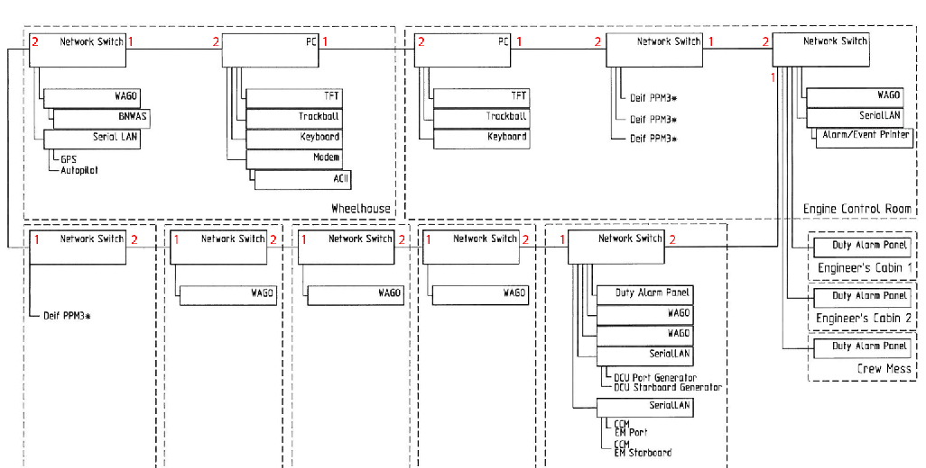

Figure 10‑2: numbering the drawing

As you can see we have numbered all the devices with the numbers 1 and 2. Now number 1 is the “IPAddressUp” and number 2 is the “IPAddressDown”. So, for example. for the PC (let’s assume it has key number 3035) the number 1 side , in the sensorlist IPAddressUp, will be 172.16.30.35. the number 2 side, in the devicelist the IPAddressDown, will be 172.17.30.35. You’ll notice that de down-side is considered as another ring and will get another IP-range.

While the Switches do not have an IP-address they need not have one of the above mentioned IP addresses assigned. More on how to build that in to the devicelist in chapter

10.5.11

The interfaces such as the Wago, the SerialLan etc. will get their own IP address as well as a port connection (also see Chapter 10.5.11)

### IPAddressUp2- IPAddressDown2

If we use a redundant system or a double wired system. The second pair of cabling will be treated the same way as described above. With this difference that the connections are new rings so they get separate IP ranges.

## Mac addresses

### Introduction

To be identified in a network it is sometimes needed that the MAC address is available to distinguish two or more of the same devices. The MAC address is a unique number that is only conjugated to one device. So if there are two or more Moxa’s on a network, FT needs to separate them with their distinct MAC number. For these devices you need to fill in the MAC address in the devicelist.

### MACAddressUp(2)- MACAddressDown(2)

In the devicelist you fill in the MAC address behind the device or interface you have the address from. Normally devices like this will be connected on a single point so you will only have to fill in the “MACAddressUp” or, in case of double wiring the “MACAddressUp2”.

On the rare occasion that a device is connected to port 1 (IPAddressUp) and to port 2 (IPAddressDown) of another device you may have to use the “MACAddressDown”